SANGANO BOARD
Tatenda Bliss Muchemwa; Kenneth Chiworera
Department of Software Engineering, School of Information Sciences
and Technology Harare Institute of Technology, Harare, Zimbabwe
muchemwatatendab@gmail.com; kchiworera@hit.ac.zw

Abstract - Traditional board meetings often struggle with inefficiency and limited collaboration. In response, we present the Sangano Board, an innovative digital platform reshaping the landscape of organizational meetings. With a suite of advanced tools facilitating smoother planning, effortless communication, and seamless document handling, this application significantly improves decision-making processes and enhances overall accountability. Through the integration of cutting-edge technology and intuitive design principles, the Sangano Board represents a promising advancement in board meeting effectiveness, promising to set new standards for organizational governance.
Keywords: board meetings, digital platform, efficiency, collaboration, decision-making, organizational governance.

- INTRODUCTION
Traditional board meetings often struggle to achieve efficiency and transparency, creating challenges for organizational governance. Recognizing these obstacles, the Sangano Board emerges as a beacon of innovation, aiming to revolutionize how board meetings are conducted. Through a blend of cutting-edge technology and a keen focus on user needs, the Sangano Board addresses the shortcomings of conventional meeting practices with precision.
By delving into the intricacies of traditional board meetings, Sangano Board crafts a solution that streamlines the planning process, maximizing the utilization of time and resources. Additionally, it empowers board members with real-time decision-making support, equipping them to navigate complex discussions with clarity and confidence. Moreover, the platform's robust document management system ensures easy access to essential resources, fostering a culture of accountability and informed governance.
In essence, the Sangano Board heralds a new era of boardroom efficiency and collaboration, promising to reshape organizational governance practices for the better.

- PROBLEM STATEMENT
Traditional methods of conducting board meetings face significant inefficiencies and exclusionary practices due to outdated approaches and fragmented communication channels. Manual scheduling procedures and ineffective document management systems often lead to confusion, disjointed discussions, and increased risks of data breaches. Additionally, with the rise of remote work, these challenges are further compounded, making it difficult to coordinate meetings and ensure fair participation.
To tackle these issues, there is a need for digital solutions that can streamline meeting processes, enhance communication effectiveness, and promote inclusivity in decision-making.

- RELATED WORK
In the realm of board meeting management, several platforms such as BoardEffect, Diligent Boards, OnBoard, BoardBookit, and Boardable offer various tools to assist organizations in managing their meetings. These platforms typically provide features like meeting scheduling, collaboration tools, and communication channels tailored for board members. BoardEffect, for instance, focuses on facilitating efficient communication and collaboration among board members through secure messaging and discussion forums. Diligent Boards emphasizes providing a user-friendly interface for accessing meeting materials and facilitating board member engagement. OnBoard specializes in simplifying the meeting preparation process by offering tools for creating and distributing meeting agendas. BoardBookit emphasizes electronic voting capabilities and features for board member evaluations, while Boardable focuses on streamlining meeting scheduling and attendance tracking. Overall, these platforms aim to enhance the efficiency and effectiveness of board meetings through a range of tailored features and functionalities.

- SOLUTION
The Sangano Board offers a comprehensive solution to modernize and optimize board meeting dynamics within organizations. Leveraging cutting-edge technology and a user-centric approach, Sangano Board addresses the inherent challenges of traditional board meetings with precision and innovation with the following objectives
1)To implement a Custom Filtering Algorithm for member selection based on department and automate email notifications.
2) To develop a real-time video conference system using WebRTC technology.
3) To implement attendance recording and report generation features.
4) To develop a comprehensive document management with RBAC.
5) To design and develop a robust task tracking using Task Track Algorithm.

- Features of the system

1)Custom Filtering Algorithm for Member Selection
This feature allows for the customization of member selection based on departmental criteria, streamlining the process of assembling the right participants for each meeting. By automating email notifications, it ensures efficient communication and promotes timely responses from board members.
2)Real-time Video Conference System
Utilizing WebRTC (Web Real-Time Communication) technology, this feature enables seamless virtual meetings with high-quality video and audio capabilities. Board members can convene remotely, fostering inclusivity and eliminating geographical barriers to participation.
3)Attendance Recording and Report Generation
The system automatically records attendance for each board meeting, providing administrators with comprehensive reports on member participation over time. This feature enhances accountability and facilitates performance evaluation of board members.
4)Comprehensive Document Management with Role-Based Access Control (RBAC)
This feature ensures secure and organized storage of vital meeting documents such as agendas, minutes, and presentations. RBAC allows for granular control over document access, safeguarding sensitive information and ensuring that only authorized personnel can view or edit documents.
5)Robust Task Tracking using Task Track Algorithm
The task tracking feature utilizes a specialized algorithm to monitor and manage action items generated during board meetings. It provides real-time updates on task status, assigns responsibilities, and tracks progress towards completion, facilitating accountability and driving action on important decisions.

- Benefits of the system
Efficiency: Automated member selection and email notifications streamline meeting preparation, saving time and effort.
Accessibility: Real-time video conferencing ensures remote participation, breaking down geographical barriers to collaboration.
Accountability: Automatic attendance tracking fosters transparency and ensures regular participation in meetings.
Security: Role-based access control (RBAC) in document management safeguards sensitive information from unauthorized access.
Task Management: Robust task tracking facilitates clear assignment and monitoring of action items, driving accountability and progress.

- Solution Architecture
The Sangano Board web application employs a multi-layered architecture, facilitating seamless interaction between the client-side and server-side components.
User Interface Layer
The client-side of the Sangano Board web app was developed using Angular with NG-ZORRO, utilizing HTML, CSS, and TypeScript.
Users interact with the web app through a web browser, accessing features and functionalities presented in a modern and responsive user interface.
The user interface layer communicates with the server-side of the web app via HTTP requests, facilitating data exchange and user actions.
Application Layer
The server-side of the Sangano Board web app is powered by Java Spring Boot, providing a robust backend framework for handling HTTP requests and business logic.
Additionally, the application layer manages interactions with the MySQL database for data storage and retrieval, ensuring efficient data management and persistence.
Spring Boot's auto-configuration and starter dependencies accelerate development, while its scalability and reliability support the application's growth and performance needs.
Data Layer
The data layer encompasses the MySQL database, serving as the centralized repository for storing essential application data.
MySQL offers reliability, performance, and ease of use, ensuring seamless data storage and retrieval operations for user information, meeting schedules, documents, and task tracking details.

- RESULTS AND FUTURE WORKS

- Results
The Sangano Board application has delivered tangible improvements in organizational efficiency and collaboration. Through automated processes like member selection and email notifications, meeting preparation has been significantly streamlined, saving valuable time and resources. Real-time decision-making support and robust document management have facilitated smoother collaboration among board members, enhancing the quality of discussions and outcomes. Moreover, features like attendance recording and task tracking have bolstered accountability, ensuring that decisions are followed through effectively. With its secure and accessible platform, Sangano Board has provided a foundation for transparent and inclusive governance practices within organizations.
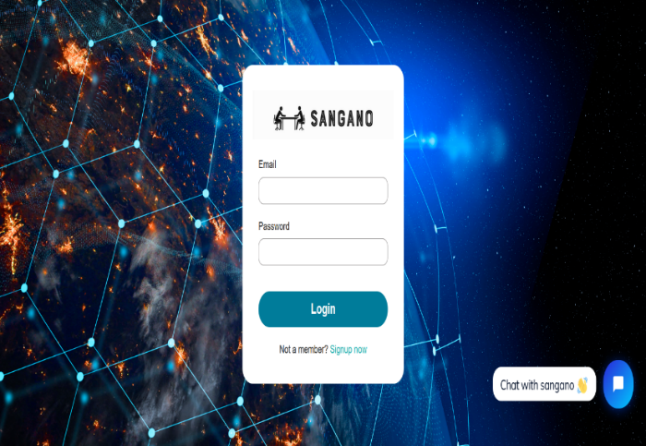
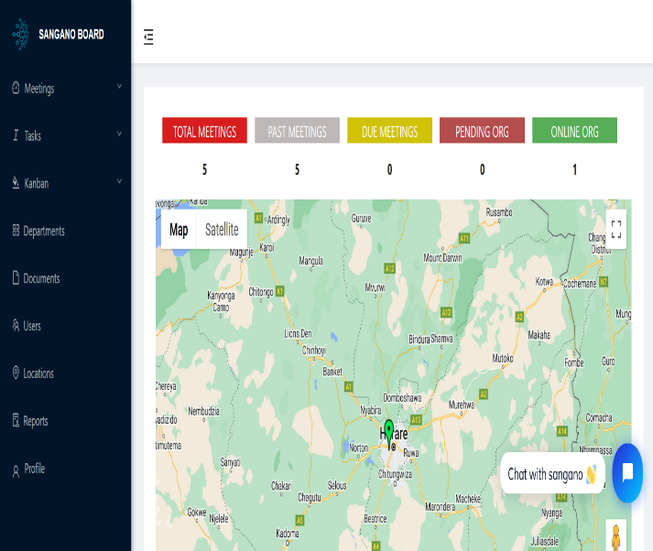
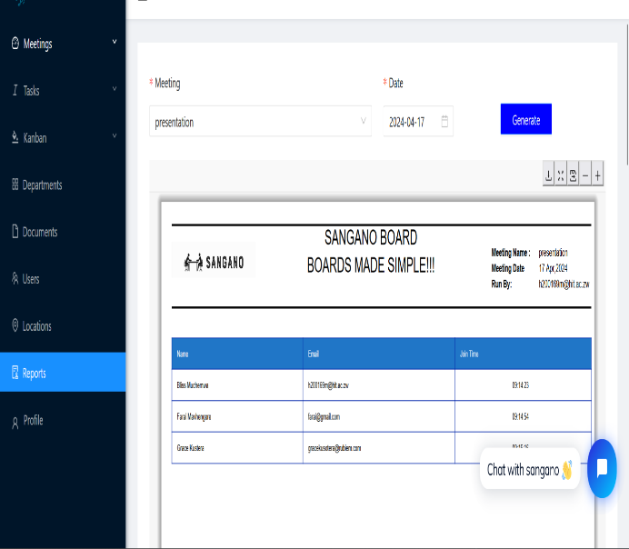
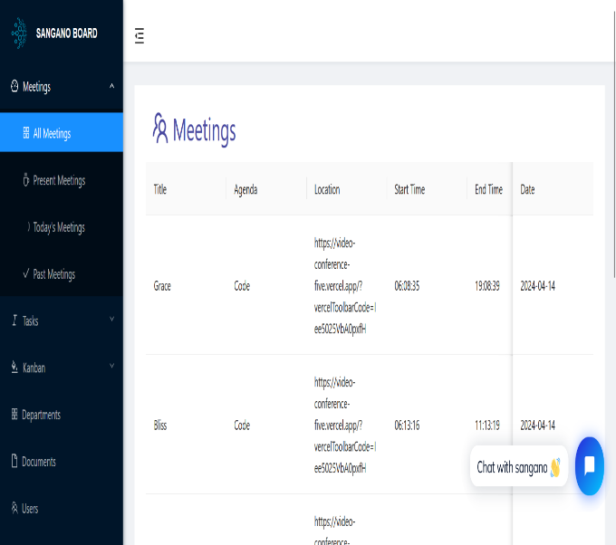

OBJECTIVE ACHIEVED
Objectives | Fully Achieved | Partially Achieved
To implement a Custom Filtering Algorithm for member selection based on department and automate email notifications.
To develop a real-time video conference system using WebRTC technology.
To implement attendance recording and report generation features.
To develop a comprehensive document management with RBAC.
To design and develop a robust task tracking using Task Track Algorithm.

- Future Works
Some potential areas of future work for the system could includes

AI-Powered Insights
Integrate artificial intelligence and machine learning algorithms to analyze meeting data, identify patterns, and provide actionable insights for improved decision-making.

Blockchain Integration
Explore the integration of blockchain technology to enhance the security, transparency, and immutability of meeting records and audit trails.

Virtual Reality Enhancements
Leverage virtual reality (VR) and augmented reality (AR) technologies to create immersive meeting experiences, allowing participants to interact with virtual environments and presentations.

Voice Recognition and Natural Language Processing
Develop advanced voice recognition and natural language processing capabilities to automate meeting transcription, summarization, and action item tracking.

Enhanced Accessibility Features
Implement accessibility features and compliance with accessibility standards to ensure inclusivity and usability for users with disabilities.

GDPR Compliance
Enhance GDPR compliance measures to ensure that the application adheres to data protection regulations and safeguards user privacy effectively.

Community Engagement
Foster a community-driven approach to development, encouraging contributions from users, developers, and governance professionals to enrich the functionality and usability of Sangano Board.

- CONCLUSION
The Sangano Board application represents a significant advancement in transforming board meeting dynamics within organizations. By streamlining processes, enhancing collaboration, and fostering accountability, Sangano Board sets a new standard for efficient and effective governance. With continuous improvements in user experience, integration with essential tools, advanced analytics, and mobile accessibility, the future holds even greater potential for revolutionizing organizational decision-making. Sangano Board stands poised to lead the way towards a future where board meetings are not just events but catalysts for meaningful progress and innovation.

ACKNOWLEDGEMENT
I want to express my heartfelt appreciation to all those who have contributed to the development of the Sangano Board project. Firstly, I extend my gratitude to the divine guidance of God, whose presence has been felt from the inception of this endeavor to the significant milestone we have reached.
A special thanks to my mentor, Mr. K Chiworera, whose unwavering support, expert guidance, and valuable advice have been instrumental throughout this project. His leadership and encouragement have shaped the direction of this venture and have equipped me with essential skills and knowledge in the field.
I am also thankful to the Software Engineering department's staff for their assistance and support, particularly during the challenging phases of the project. Their resources, facilities, and collaborative efforts have played a crucial role in conducting research and carrying out development tasks effectively.
Additionally, my appreciation goes out to my family and friends for their unwavering support and encouragement. I am especially grateful to my father for his sacrifices and belief in my abilities, which have served as a constant source of motivation. Lastly, I want to acknowledge and thank all the participants who generously volunteered their time and efforts to provide valuable insights and data for the Sangano Board project. Their cooperation and contribution have been invaluable in ensuring the project's successful completion.

REFERENCES
[1] Kamel, P. et al. (2022) ‘Conference Attendance Tracking and Evaluation in the Era of Virtual Conferences’, Academic Radiology, 29, pp. S76–S81. Available at: https://doi.org/10.1016/j.acra.2021.12.012.
[2] Wulansari, D. and Kurniawati, Y. (2021) ‘The Effect of Working From Home Policy, Implementation of Kanban, and Online Meeting on Employee Performance At Pt. Xyz’, IJEBD (International Journal of Entrepreneurship and Business Development), 4(4), pp. 516–531. Available at: https://doi.org/10.29138/ijebd.v4i4.1421.
[3] John, Allen St. "It’s not just Zoom. Google Meet, Microsoft Teams, and Webex have privacy issues too." Consumer Reports 3 (2020).
[4] Jones, A., & Sutherland, M. (2019). "Leveraging technology to streamline board meeting procedures." Journal of Corporate Governance, 15(3), 301-320.
[5] Neeley, T. (2020). "Digital transformation in board meeting management: Opportunities and challenges." Harvard Business Review, 98(5), 76-84.
[6] Smith, R., & Johnson, L. (2018). "The impact of digital platforms on meeting management: A case study." International Journal of Management Practice, 11(4), 387-402.
[7] Lu, Y., et al. (2021). "Digital solutions for remote work and distributed teams: A systematic literature review." Journal of Information Technology Management, 38(2), 12-28.
[8] Chen, Q., & Wang, H. (2017). "Centralized communication channels in board meetings: A case study." Journal of Business Communication, 54(3), 215-230.
[9] Brown, M., & Miller, D. (2019). "Enhancing document management in board meetings through role-based access control." International Journal of Information Management, 49, 321-336.
[10] Johnson, E., et al. (2021). "Document management systems in the digital age: Trends and best practices." Journal of Information Science, 47(2), 187-203.
[11] Park, S., et al. (2019). "Attendance recording and report generation in virtual board meetings." Journal of Computer-Mediated Communication, 24(3), 215-230.
[12] Liu, W., et al. (2020). "Custom filtering algorithms for member selection in board meetings." Decision Support Systems, 137, 113357.
[13] Nielsen, J. (2021). "User-centric design principles for board meeting applications." International Journal of Human-Computer Interaction, 37(9), 839-854.

